Launching and Terminating a T2 micro EC2 instance

This is the Dashboard of the EC2

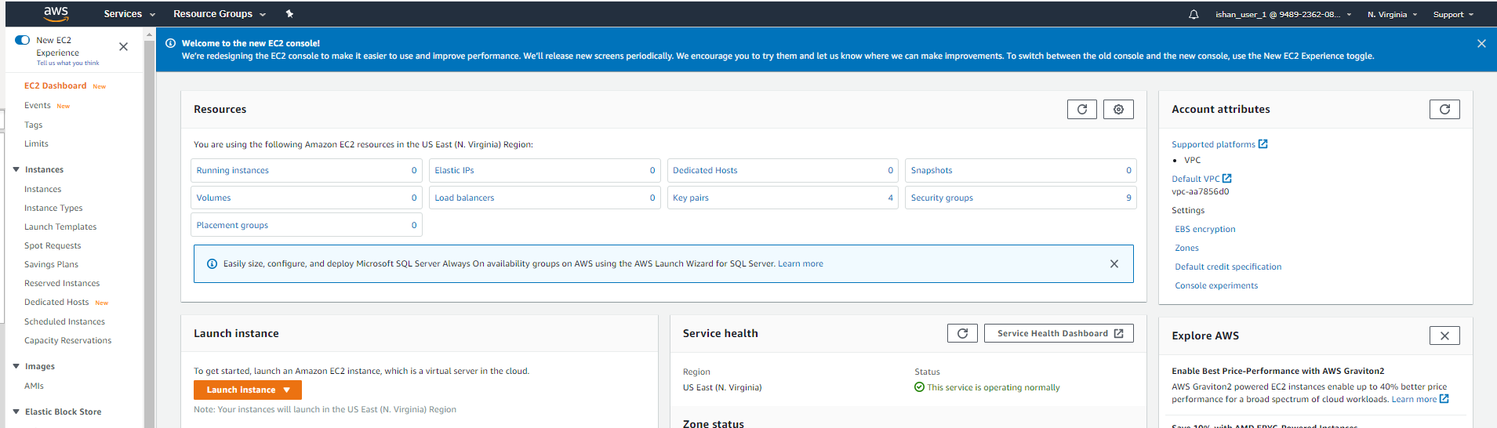

We click on launch Instance and then select the AMI machine.

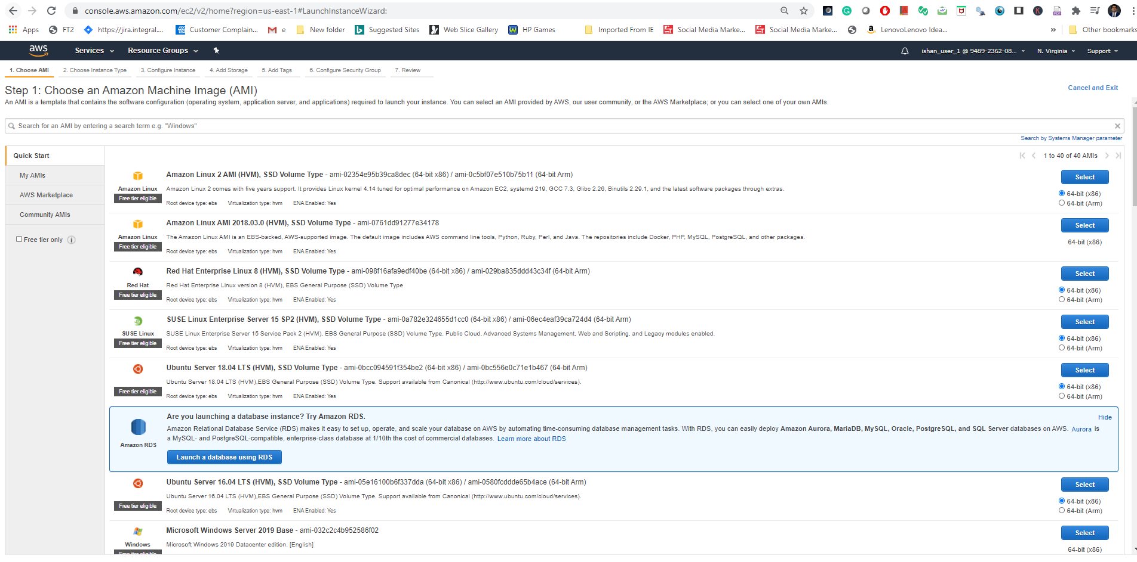

Now we have to select the type of Instance

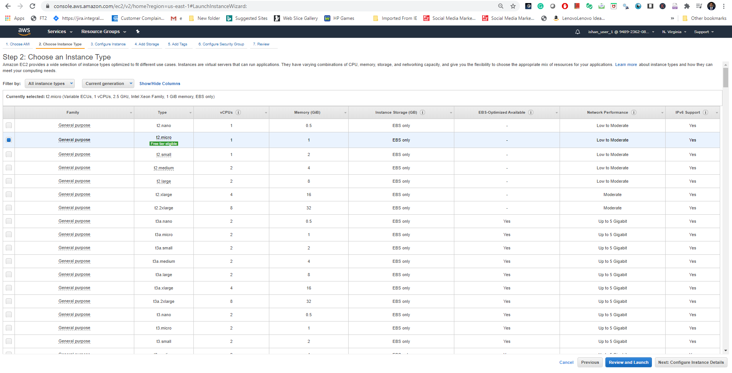Here we can configure the out EC2 instance.

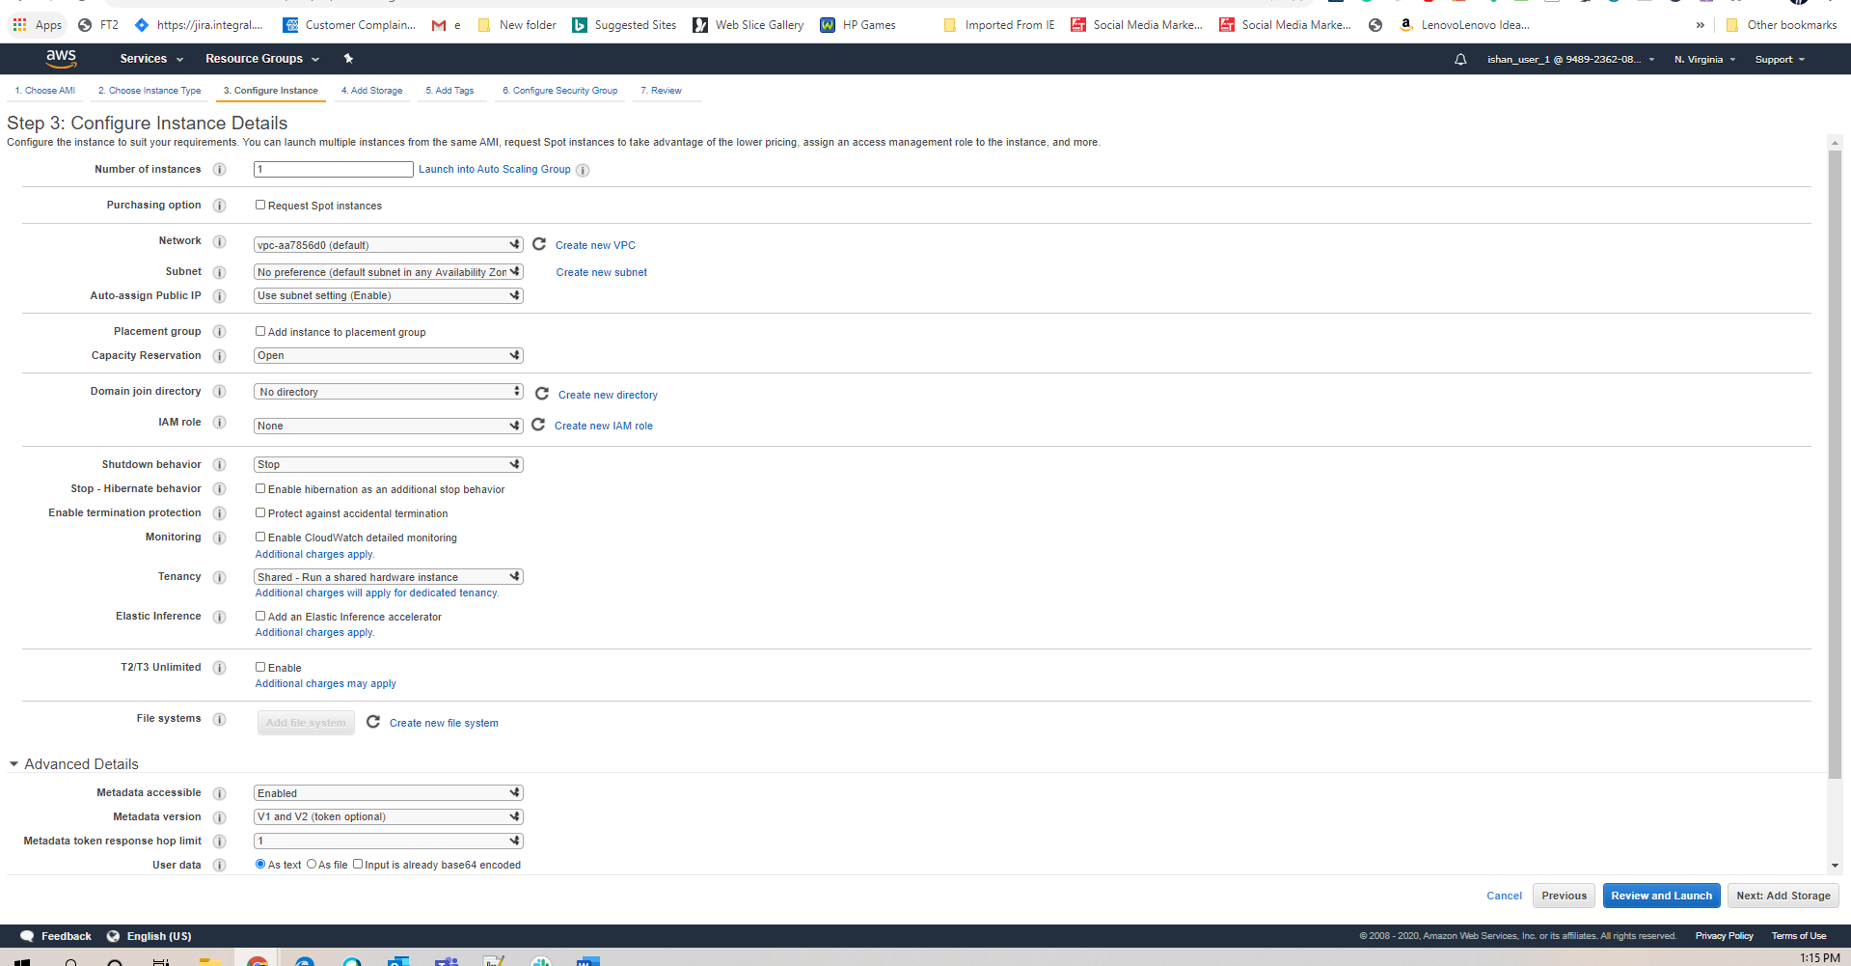

Selecting an EBS root volume which is just like an HDD

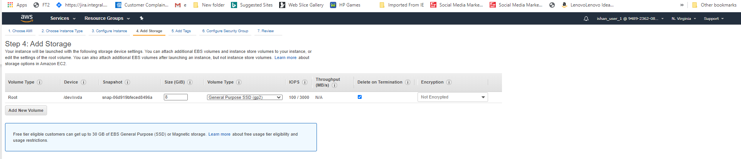

Here we have to choose the Security Group

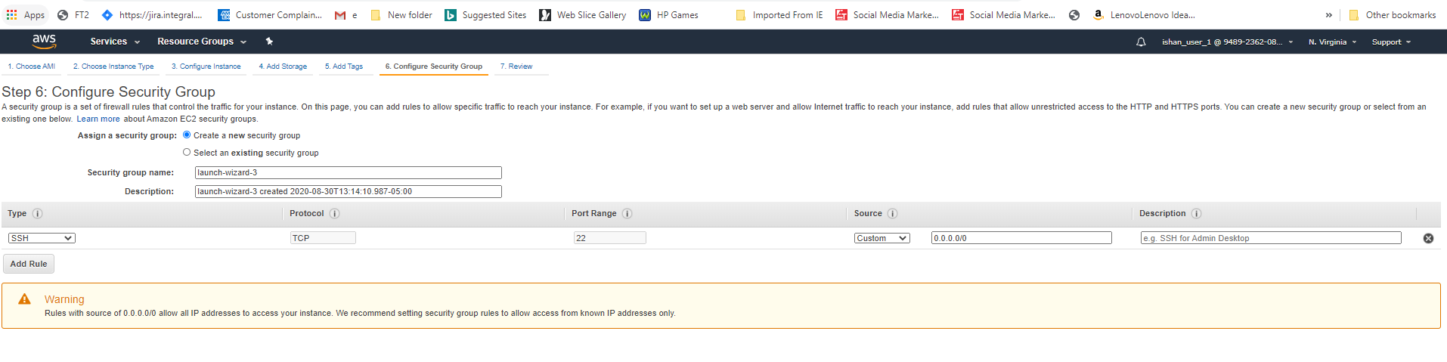

Selecting the default Security Group

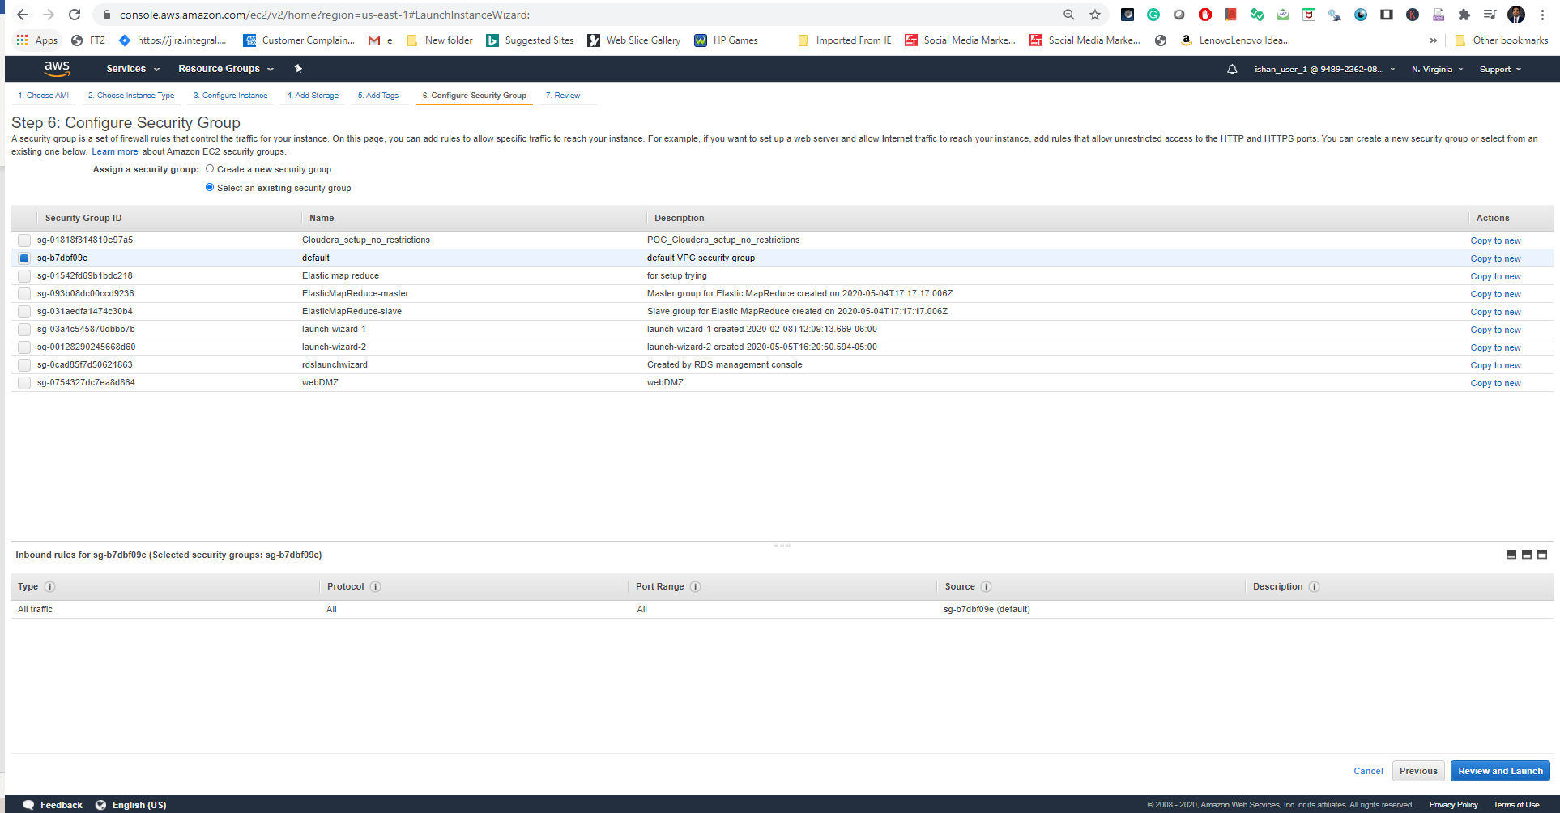

Previewing the configuration before launching the EC2

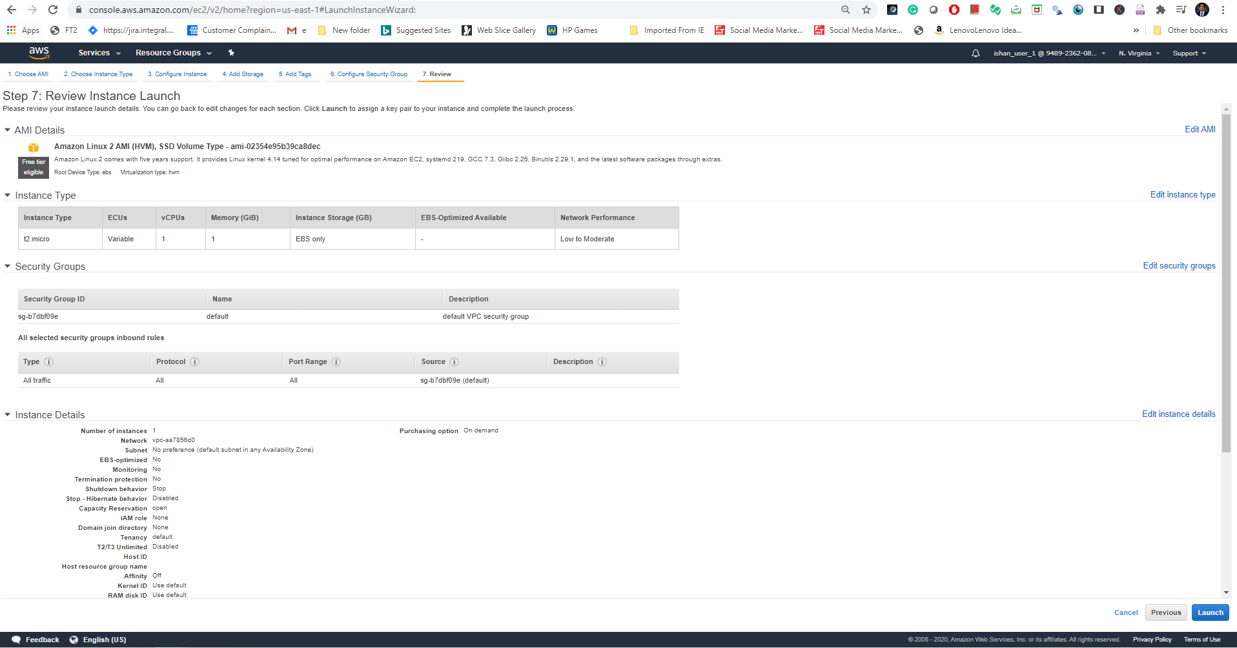

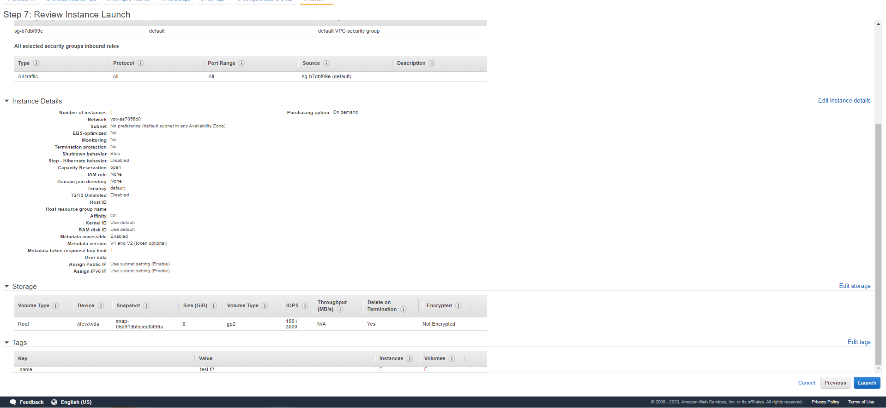

Choosing the key pair

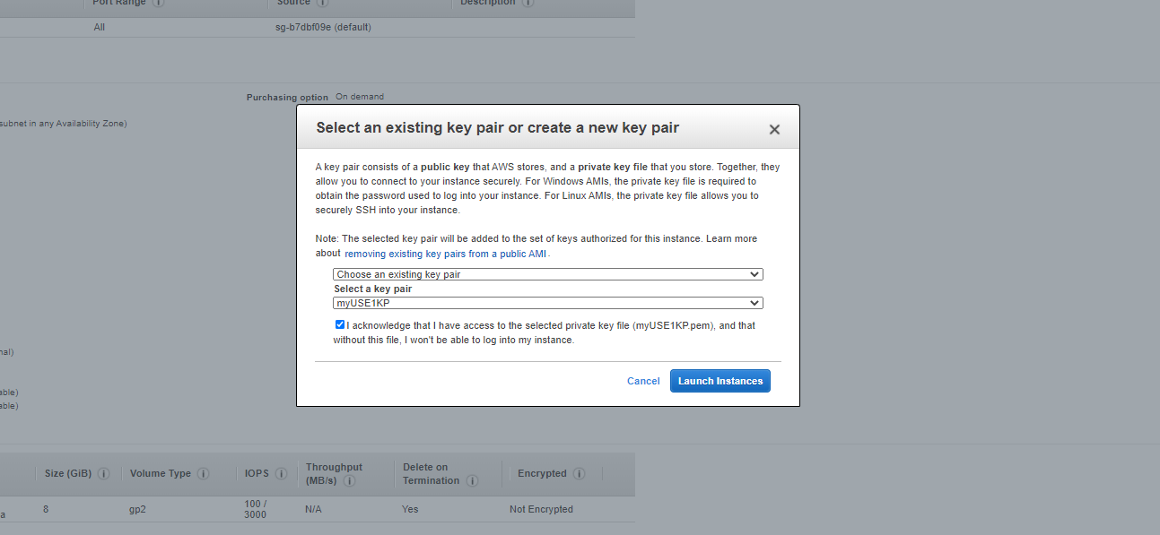

After clicking the launch instance the instance will start to provision.

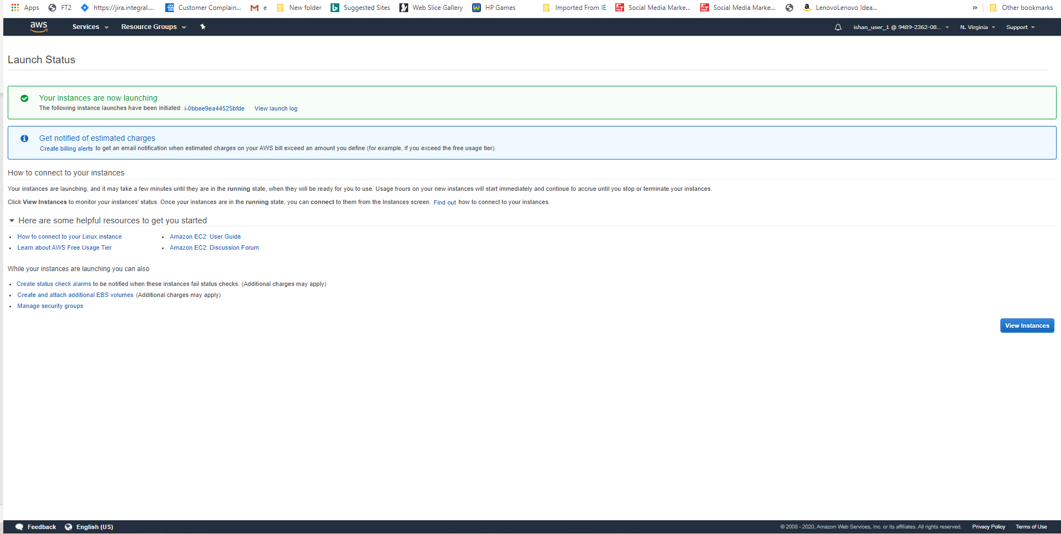

Here we can see that it is on the pending state.

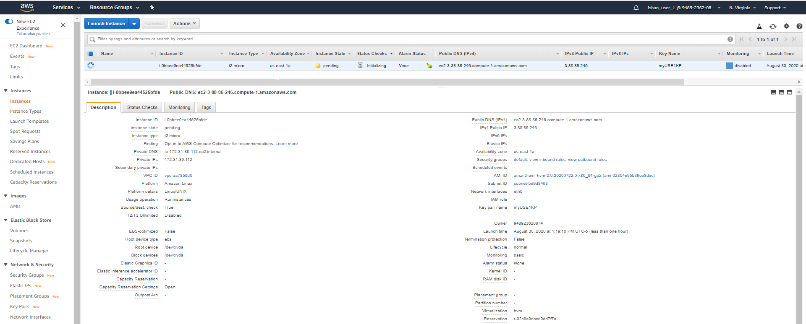

After a few minutes the status of the EC2 has changed to running



Now terminating the EC2 instance.

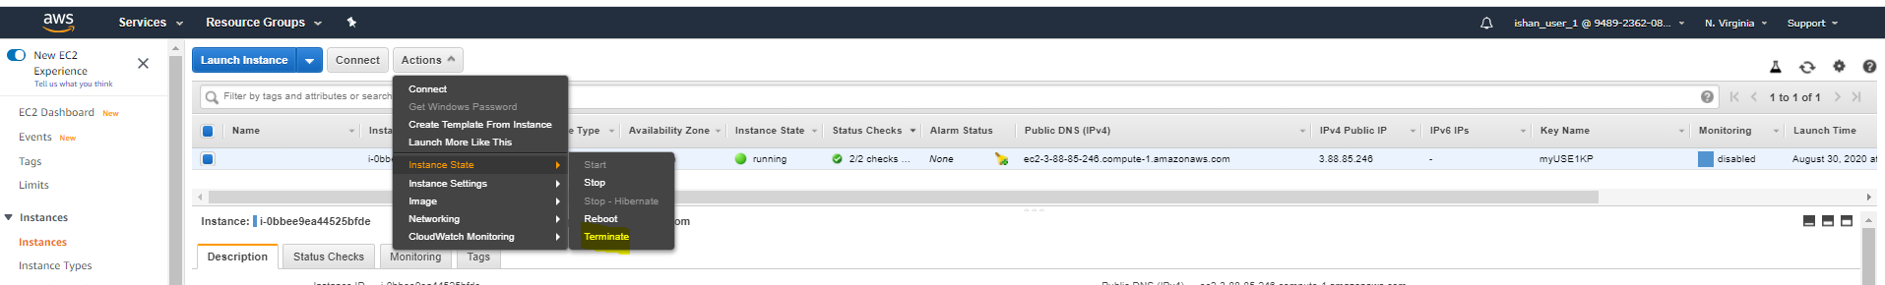

Click on the yes,Terminate button.

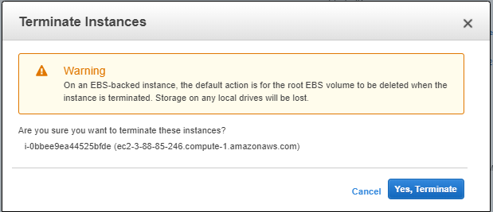

EC2 is on a shutting down state.



Finally EC2 has terminated

